A Heuristic Approach to Quadrature Down Conversion

Sreeja Guduri   
International Institute of Information Technology,  
Hyderabad, India.   
sreeja.guduri@students.iiit.ac.in  
2021102007  
Paridhi Prasad  
International Institute of Information Technology,  
Hyderabad, India.  
paridhi.prasad@students.iiit.ac.in  
2021102008  
Nobhendu Chowdhury  
International Institute of Information Technology,  
Hyderabad, India.  
nobhendu.chowdhury@research.iiit.ac.in  
2021112001

*Abstract*—This paper proposes a model for a quadrature down-conversion circuit, which produces in-phase and quadrature-phase intermediate frequency signals from an input signal. The approach described in this paper realizes the down-converter by using a Wien-bridge oscillator, a mixer, and a low-pass filter.

Keywords—oscillator, filter, mixer, integrator, amplifier, divider, phase-shifter, down-conversion

# Introduction

Quadrature down-conversion is a method of reducing the frequency of band-limited signals by sampling them at lower rates. This fulfills the purpose of simplifying the processing stages that come subsequently. It also serves to improve the quality of communication and interference mitigation and is widely used by modern-day wireless receivers such as Bluetooth, Wi-Fi, and WLAN. This paper discusses a project where a system of circuits was used to implement down-conversion, with a particular range of specifications.

The proposed down-converter model consists of three main subcomponents: an oscillator, a low-pass filter, and a switch. The oscillator produces sinusoidal waves, and the mixer multiplies the input signals with the generated sine and cosine waves. After this, the in-phase and the quadrature-phase components of the input signal are passed through the low-pass filters, which pass the required frequency, and hence the final output is produced.

1. The basic circuit structure of the down-converter.

Apart from the circuit structure depicted in Figure 1, there are also parts of the circuit system that perform intermediate functions, including the voltage divider, integrator, and the phase-shifter. Their coupled working ensures the functioning of the down-converter.

# Oscillator Design

## The Wien-Bridge Oscillator

The oscillator executes the first step of down-conversion, i.e., it produces the sinusoidal signals that are eventually mixed with the input signal and split into quadrature signals.

The Wien-bridge oscillator generates sine waves by a feedback mechanism for the op-amp. Both the inverting and non-inverting inputs receive feedback. In the Wien-bridge configuration, the passive feedback network employs zero phase shift (rather than 180°), which is why the amplifier must provide a positive gain.

1. The basic circuit structure of the Wien-bridge oscillator.

The feedback in the non-inverting loop consists of a high-pass filter and a low-pass filter. This is how the oscillations are produced in the circuit. The frequency of the produced oscillations is described by,

$$f_{r}=\frac{1}{2π\sqrt{R_{1}C_{1}R_{2}C_{2}}}$$

This value, $f_{r}$, is the *resonant frequency*. For the oscillations to start, the inverting loop gain must be at least 1, which can be achieved if $\frac{R_{1}}{R_{2}}=$ 2. This is called the Barkhausen criterion.

## The Inverting Integrator

The integrator outputs the time-integral of the received input signal. This is achieved by using a capacitor in the negative feedback loop (inverting amplifier configuration) and a resistor at the input.

1. The basic circuit structure of the integrator.

The integrating action of the circuit can be analyzed using Kirchhoff’s current laws.

The input at the non-inverting branch is grounded, the input at the inverting branch passes through the capacitance $C_{3}$, and hence, the current *iI (t)* in the inverting branch can be written as,

$$i_{I}(t) = \frac{v_{I}(t)}{R_{5}}=C_{3}\frac{dv_{I}}{dt}$$

$$⟹v_{O}(t)= –\frac{1}{R_{5}C_{3}}\int_{0}^{t}{v_{I}(t) dt}$$

where, $v_{O}(t)$ is the output voltage.

In the absence of R6, the initial current flowing through the feedback loop charges the capacitor until it saturates, after which it acts as an open circuit. This is prevented by connecting the resistor R6 through which the current flows after the saturation of the capacitor.

## The Non-Inverting Amplifier

The amplifier is used to scale the amplitude of the cosine wave (generated as the output of the integrator) to the required value. This is realized by using an amplifier in the non-inverting configuration, that is, the output is fed back to the inverting terminal at input through a resistor divider.

The gain of the negative feedback amplifier is given by,

$$A_{v} = 1 + \frac{R_{9}}{R_{10}}$$

The values of the resistances are thus chosen based on the value of the desired gain. Since the output cosine wave from the integrator has an amplitude of 220mVp-p we would need a gain of around 4.4.

Using the equation described above,

$$4.4 = 1 + \frac{R_{9}}{R_{10}}$$

$$\frac{R_{9}}{R_{10}} = 3.4$$

Based on this calculation, the values for the resistors were decided as 3.34kΩ and 1kΩ.

1. The basic circuit structure of the amplifier.

## The Voltage Divider

The voltage divider is used to decrease the amplitude of the sine wave generated by the Wien-Bridge oscillator to the required value.

The output voltage across resistor R13 is,

Since the sine output of the Wien-Bridge oscillator has an amplitude of 1.67 Vp-p, the output amplitude will be

$$v_{out} = \frac{1.67 × 1k}{1k + 784} = 0.94≈1 V_{p-p}$$

which is the required amplitude.

1. The basic circuit structure of the amplifier.

## The Phase Shifter

1. The basic circuit structure of the amplifier.

The phase shifter is used to correct the phase of the sine wave produced by passing it through a series of unity feedback op-amp buffers. The phase difference between the cosine and sine waves arises due to the op-amps in the amplifier and integrator circuits. Each op-amp in the circuit causes a slight phase shift, resulting in the final sine wave being at approximately 90° phase difference with the cosine wave.

## Simulated plots

The transient plots of voltages at the output nodes(from Figs. 7 & 8) can be analyzed for different values of input frequency, as observed in Figs. 9 – 14.

1. Sine output from the Wien-bridge oscillator having a frequency 100kHz and amplitude 1.52 Vp-p

1. Cosine output from the inverting integrator frequency 100kHz and -amplitude 240 mVp-p.

1. Scaled cosine output from the non-inverting amplifier having the required amplitude of 500 mVp-p.

1. Sine output from the voltage divider having the required amplitude of 500 mVp-p.

1. Phase corrected sine output from the phase shifter circuit.

## Experimental results

The above circuit was constructed on a breadboard and the observations were noted using a Digital Storage Oscilloscope (DSO). The op-amps used was given a DC voltage of 12 V.

1. DSO plot (with FFT) from the Wien-Bridge oscillator having a frequency of 100kHz and an amplitude of 1.67 Vp-p.

1. DSO plot of the sine and cosine waves after the amplifier and the voltage-divider having amplitudes of 1 Vp-p and a frequency   
   101 kHz.

1. DSO plot of the sine and cosine waves at the final stage, i.e., after the phase shifter having a phase difference of 90º.

# Mixer Design

## The Switch

The switch, also called the mixer, serves the purpose of multiplying two signals of different amplitudes and frequencies. In this design of the down-converter, it is used to mix the input signal and the generated signal (from the oscillator). One signal is applied at the gate terminal and the other at the source terminal. The mixed signal is received at the drain terminal.

1. The basic circuit structure of the amplifier.

The functioning of the MOSFET in the saturation mode (Vgate > Vthreshold) is ensured by applying a DC voltage, Vbias to the gate. To prevent Vbias from affecting the amplitude or frequency of the input signal (sinusoid), we use a low capacitance Cc so that the nodes are isolated. Similarly, a high resistance RBIAS prevents the input signal from flowing into the ground.

CMOSN, as shown in Fig. 15, was parameterized with the following Spice definition:   
  
CMOSN l=0.18u w=0.4u ad=0.18p as=0.18p pd=1.7u ps=1.7u

The mixed signal contains the individual frequencies of the input signal and the generated signal ($⍵_{1}$& $⍵_{2}$), their sum $(⍵_{1}+⍵_{2})$ and their difference ($⍵_{1}–⍵_{2}$).

If the input signal is $v_{in} = A_{1}cos\left(⍵_{in}t\right)$*,* and the generated cosine signal is $v_{{osc}_{I}} = A_{2}cos\left(⍵_{osc}t\right)$ then the mixed signal that is obtained as the output is,

$$v_{{IF}_{I} }= v_{in}× v_{{osc}_{I}} = \frac{A_{1}A_{2}}{2}\left(cos\left(⍵_{in}t–⍵_{osc}t\right)+cos\left(⍵_{in}t+⍵_{osc}t\right)\right)$$

## The Low Pass Filter

The signal received at the drain terminal of the MOSFET is passed through a low pass filter to get the lowest frequency, i.e., ($⍵_{1}–⍵_{2}$). This is the final down-converter output.

1. The basic circuit structure of the low pass filter.

A low pass filter passes any signal with a frequency below its cut-off frequency $\left(⍵_{0}=\frac{1}{RC}\right)$. The above circuit has a resistor and a capacitive reactance $\left(X_{c}=\frac{1}{⍵RC}\right)$ in series. At low frequencies, the value of $X_{c}$ is very high, so the entire voltage drops across the capacitor, i.e., the entire input signal is passed. As frequency increases, voltage drop across capacitor decreases, and for frequencies much higher than the cut-off frequency, the entire voltage drops across the resistor and the output voltage is zero.

To obtain the required cutoff frequency of 2kHz, we choose the resistor and capacitor values based on the equation,

$$f_{cutoff} = \frac{1}{2πRC}$$

$$2 ×10 ^{3} = \frac{1}{2πRC}$$

$$⇒ RC = \frac{1}{2π × 2 ×{10}^{3}} = 80μs$$

Based on this calculation, the values for the resistor and capacitor used in the low pass filter were decided as 8kΩ and 10nF respectively.

## Simulated plots

The transient plots of $v_{out_cos}$ and *cos* (from Figs. 7 & 8) can be analyzed for different values of input frequency, as observed in Fig. 9 – 14.

1. Output from the mixer (green) and the low pass filter (blue) for an input frequency f = 95 kHz.

1. Output from the mixer (green) and the low pass filter (blue) for an input frequency f = 98 kHz.

1. Output from the mixer (green) and the low pass filter (blue) for an input frequency f = 99 kHz.

1. Output from the mixer (green) and the low pass filter (blue) for an input frequency f = 101 kHz.

1. Output from the mixer (green) and the low pass filter (blue) for an input frequency f = 102 kHz.

1. Output from the mixer (green) and the low pass filter (blue) for an input frequency f = 105 kHz.

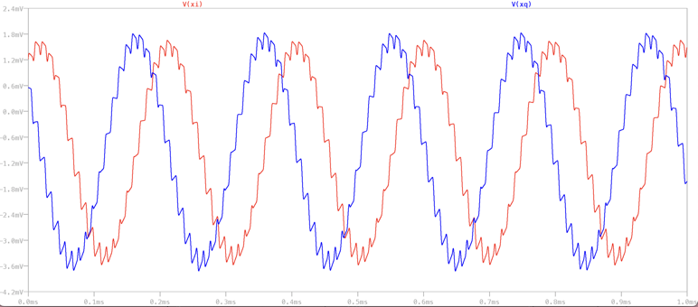

1. Phase difference of 90º between the final xI and xQ components.

The FFT (Fast Fourier Transform) plots for an input signal of frequency 95kHz and amplitude of   
100 mVp-p are shown in figures 8 & 9.

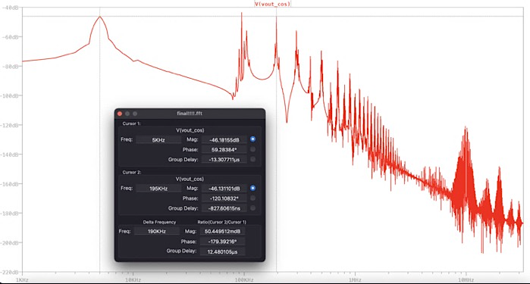

1. FFT for output from the mixer for frequency f = 95 kHz. Peaks observed at f1 = 5 kHz and f2 = 195 kHz.

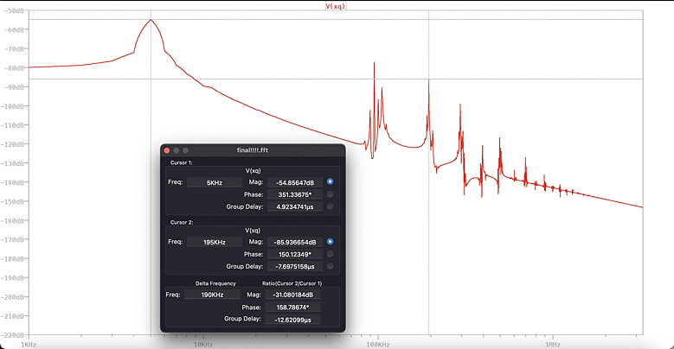

1. FFT for output from the low pass filter for frequency f = 95 kHz. Peaks observed at f1 = 5 kHz and f2 = 195 kHz.

The frequency response plot for the low pass filter (with R = 8 MΩ and C = 10 pF, giving a cutoff frequency of f = $2kHz$) is shown in figure 10.

1. Frequency response for the low pass filter with a cutoff frequency of 2kHz.

The transient response for an input signal of frequency 1kHz is given in figure 11. The filter completely passes the input signal.

1. Input (blue) and output (red) plots for input frequency of f = 1 kHz.

The transient response for an input signal of frequency 10kHz is given in figure 11. The filter does not pass the input, which is evident as a reduction in the amplitude of the output signal.

1. Input (blue) and output (red) plots for input frequency of f = 10kHz.

## Experimental results

The above circuit was constructed on a breadboard and the observations were noted using a Digital Storage Oscilloscope (DSO). $v_{in}$ was given using a waveform generator, having a frequency of 95 kHz and an amplitude of 100 m.

1. DSO output from the mixer (green) and the low pass filter (yellow) for an input frequency f = 95 kHz.

1. FFT for DSO output from the mixer for frequency of f = 95 kHz. Peak observed at f1 = 5 kHz.

1. FFT for DSO output from the mixer for frequency of f = 95 kHz. Peak observed at f2 = 95 kHz.

1. FFT for DSO output from the mixer for frequency of f = 95 kHz. Peak observed at f3 = 195 kHz.

# Performance and Review

## Simulated and measured results

1. Results Summary of proposed work

|  |  |  |  |
| --- | --- | --- | --- |
| **Sl. No.** | **Parameters** | **Simulated** | **Measured** |
| 1 | Oscillator Frequency | 100 kHz | 101.84 kHz |
| 2 | Oscillator Amplitude (I-phase) | 1 Vp-p | 1.05 Vp-p |
| 3 | Oscillator Amplitude (Q-phase) | 1 Vp-p | 980 mVp-p |
| 4 | Input frequency | 95 kHz | 95 kHz |
| 5 | IF (peaks in FFT) | 5 kHz, 95 kHz, 195 kHz | 5 kHz, 95 kHz, 195 kHz |
| 6 | Supply | 12 V | 12 V |
| 7 | VBIAS | 0.48 V | 1.8 V |
| 8 | CC | 10 µF | 10 µF |
| 9 | RBIAS | 1 MΩ | 1 MΩ |

The simulated results and the measured results are within the accepted deviation.

## Circuit shortcomings

While the circuit implementation is functional, it has certain drawbacks, such as:

### Issues with the voltage divider: The generated sine wave has a single harmonic at the required frequency; on using a resistive voltage divider, multiples of the fundamental frequncy harmonic show up in the signal, which hamper the quality and energy of the wave. Moreover, the resistive divider also introduces a lot of noise in the circuit.

### Issues with the phase-shifter: The phase-shifter sub-circuit uses a series of op-amps, each of which requires the V+ and V– dual supply. Hence, a lot of power is consumed, which brings down the efficiency of the circuit. It also takes a lot of space.

# Applications

Bluetooth Low Energy (BLE) utilises a direct down conversion technique. The baseband signals are separated into in-phase and quadrature-phase intermediate frequency signals, similar to the proposed model of the downconverter. Employing the zero IF to Direct down Conversion (DCR) system is viable for multiple reasons:

* Low power architecture
* As the signal band lies exactly on the tone of the local oscillator frequency, there is the absence of image issues
* It is convenient to use an LPF to filter out the harmonics. As the demodulated signal is at the baseband frequency of the signal. This makes the zero IF model more convenient to use than heterodyne receivers that would have required the use of high-quality band-pass filters. LPF integration chips is also more compact.

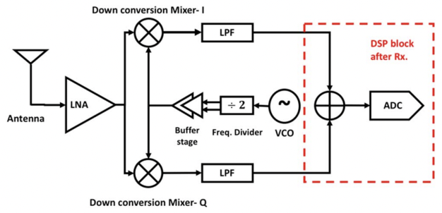

1. Schematic of the DCR used in BLE

As is evident from the block diagram in Fig. 33, the input signal received by the antenna is passed through two mixers which produces the in-phase and quadrature components. These are then passed through a LPF as discussed. The major challenge, however in designing BLE based systems is that it is hard to minimise power consumption due to the presence of various non-linear components (like MOSFET’s) in the system.

# Final Notes

## Acknowledgment

We would like to thank Dr. Abhishek Srivastava for giving us the opportunity to do this project, through which we have learnt a lot of new and interesting things. We would also like to thank Mr. Prashant Ranjan and the other lab staff for working extra hard to help support us in this project. Lastly, we would like to thank the teaching assistants for being available for doubts and clarifications.

## References

1. Microelectronic Circuits, Adel S. Sedra & Kenneth C. Smith, 7th edition.
2. Fundamentals of Microelectronics, Behzad Razavi, 2nd edition.
3. Farsheed Mahmoudi, “Quadrature Down-converter for Wireless Communications”
4. Asad A. Abidi, “Direct-Conversion Radio Transceivers for Digital Communications”
5. Ralph Holzel, “A Simple Wide-Band Sine Wave Quadrature Oscillator**”**
6. Ron Mancini, “Design of op amp sine wave oscillators”
7. M. Nasrollahpour, R. Sreekumar, F. Hajilou, M. Aldacher, “Bluetooth Low Energy (BLE) Direct Down Conversion Receiver Front End in 65nm CMOS Technology”